“Київський фаховий коледж зв’язку”

Циклова комісія Комп’ютерної інженерії

**WORK-CASE №8**

з дисципліни: «Операційні системи»

Виконала студентка

групи РПЗ-13б

Дімітрова С.П.

Перевірив викладач

Сушанова В.С.

Київ 2024

**Завдання:**

1. При роботі з серверними системами або на комп’ютерах, що досить обмежені у ресурсах, досить часто графічну оболонку вимикають або взагалі не встановлюють. Іноді виникають задачі, які здається, що без графічної оболонки виконати не можливо, проте для ОС Linux це не так. Спробуйте через термінал виконати наступні дії та поясніть за допомогою яких команд (пакетів) їх можна виконати:

* Перегляд файлів та папок через файловий менеджер у терміналі.

**Midnight Commander** is a file manager with a command line interface. It is especially useful when there is no way to run a graphical shell, but can also be used as a basic file manager in a graphical interface. It can be run in almost any command line shell and even in an SSH session.

The user interface of the programme is divided into two panels, each displaying the contents of a directory. At the top of each panel the current directory is displayed. Navigation is performed using the arrow keys. The Enter key is used to open the folder. At the very top of the programme there is a menu with options for programme settings, left and right panels, and various operations for files.

* mouse and keyboard support in the graphical interface;
* built-in viewing and editing tool with syntax highlighting;
* support for creating and unpacking archives (rpm, deb, tgz, iso, rar, cpio);
* Unicode encoding support;
* hot function keys for different actions;
* terminal line for executing commands.

To install Midnight Commander in Ubuntu, you can use the command:

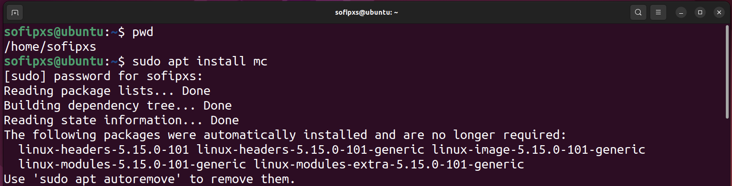

To use Midnight Commander you need to use: mc

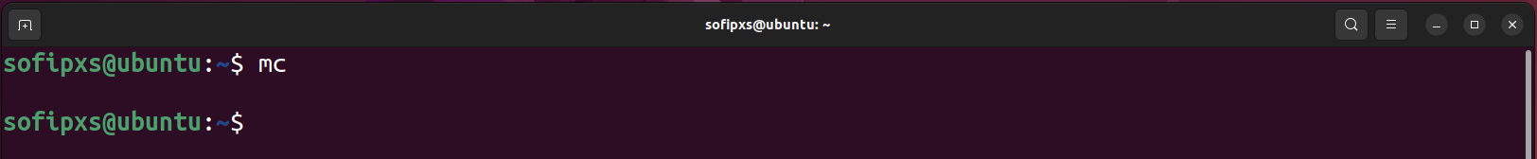

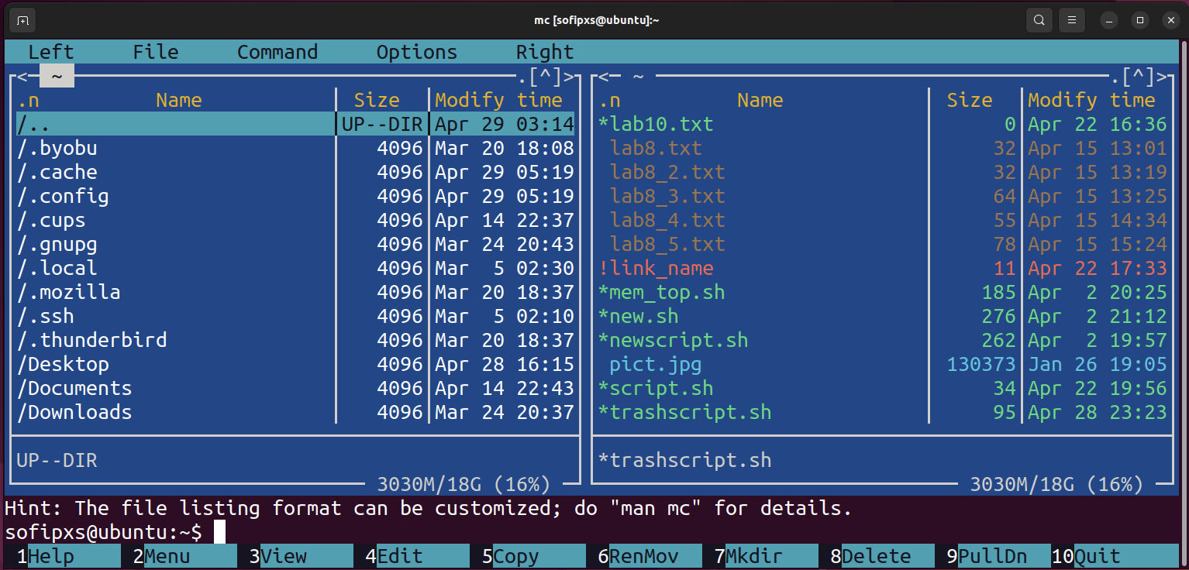

**Ranger** is another top choice when looking for a console file manager. It has a vim-like interface, previews of the selected file or directory, support for mouse bookmarks, and tabbed browsing.

To use ranger, you can use the following command:

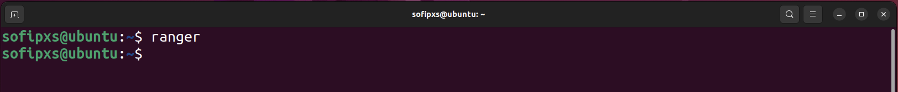

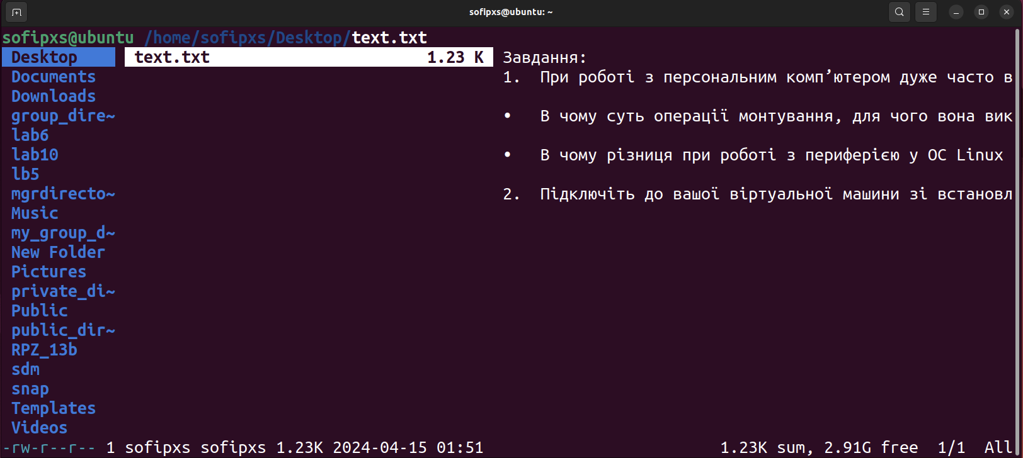

***Nnn*** is the fastest console file manager on our list. Despite having fewer features than other file managers, it is very lightweight and the closest thing to a desktop file manager in terms of features that can be accessed on the console. The interface is simple and makes it easy for new users to get used to the terminal.

To set nnn, you can use the following command:

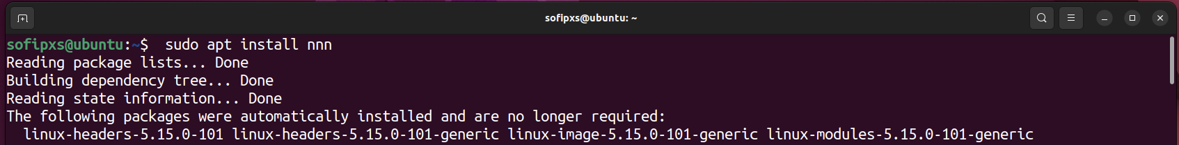



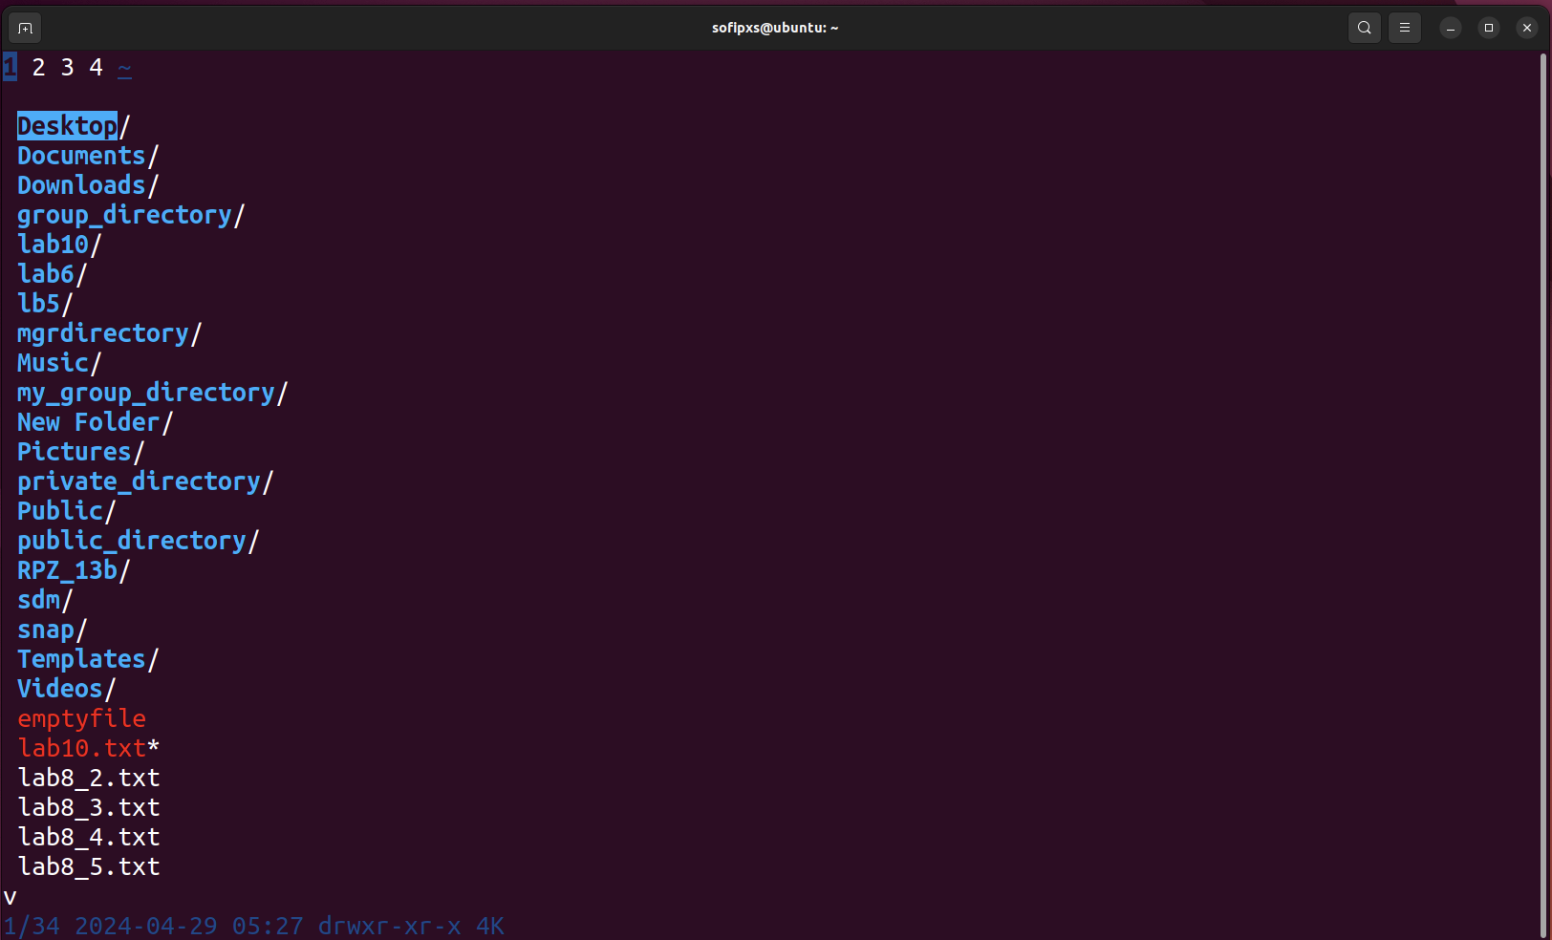

* Переглядати веб-сторінки через браузер, що працює у терміналі.

**Lynx** is a text-based web browser that is used for accessing the internet through a command-line interface. It was developed in 1992 by the University of Kansas and is still actively maintained by a dedicated group of developers. Lynx is known for its simplicity and is used primarily by individuals who prefer text-based browsing, those with low bandwidth connections, or for accessibility reasons.

To install Lynx on Linux Ubuntu, use the following command:

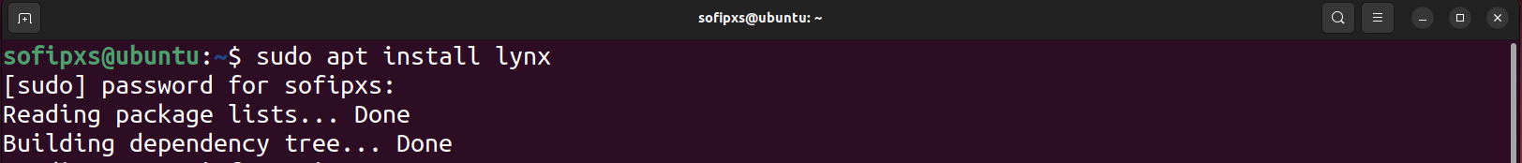

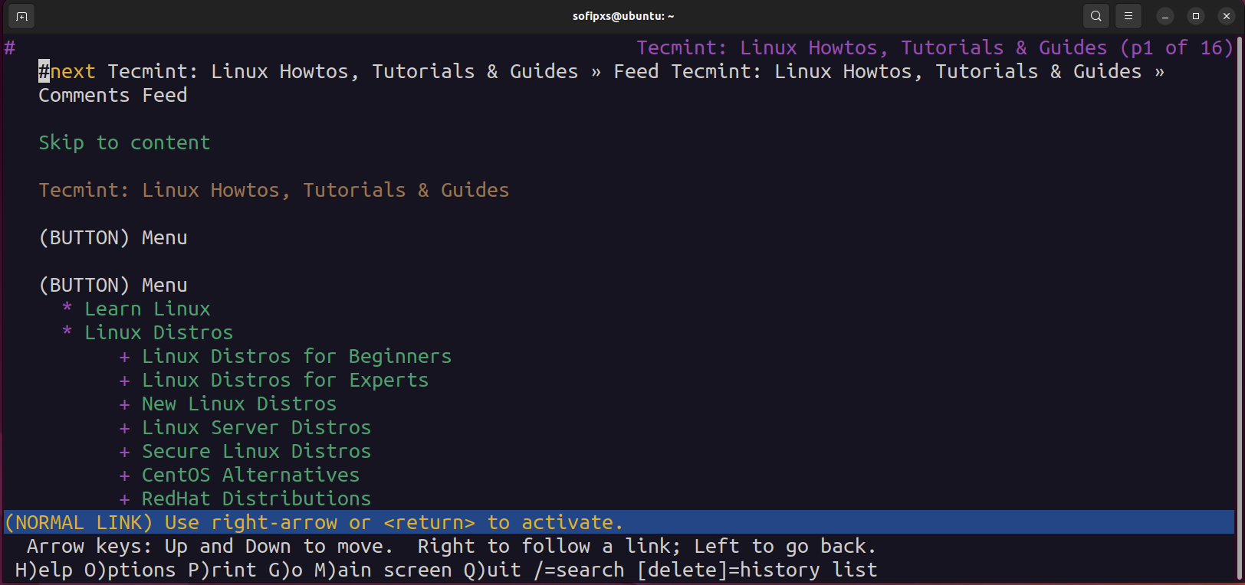

**Links** is an advanced open-source text and graphical web browser that is known for its speed, efficiency, and low resource usage. With a more modern interface compared to Lynx, Links provides a balance between functionality and simplicity. Links is compatible with HTML4, features support for CSS, and also includes limited support for JavaScript. Additionally, it offers a wide range of features such as tabbed browsing, bookmarks, and SSL support.

To install Links on Ubuntu, use :





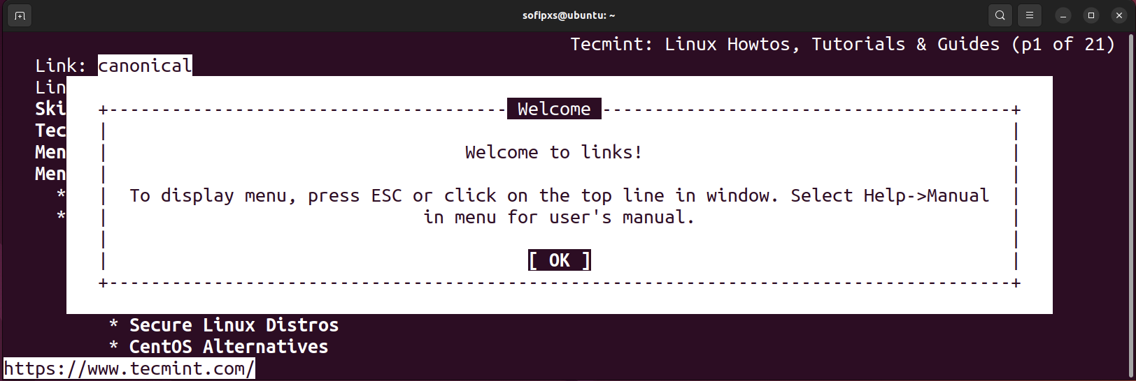

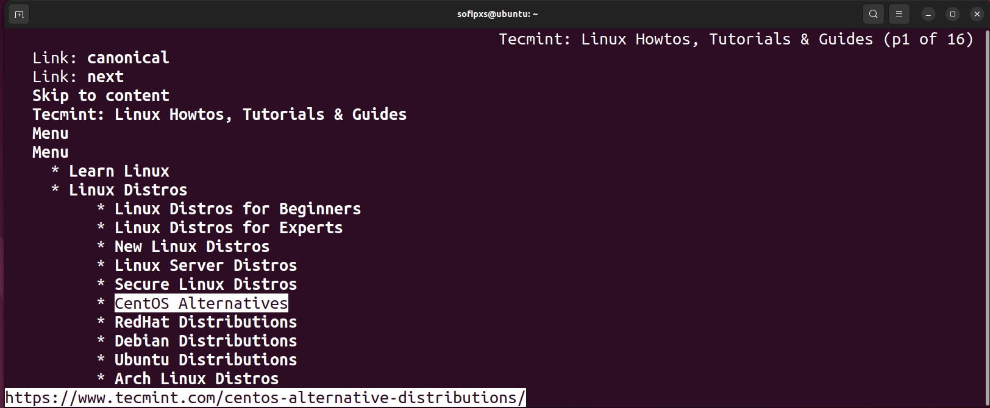

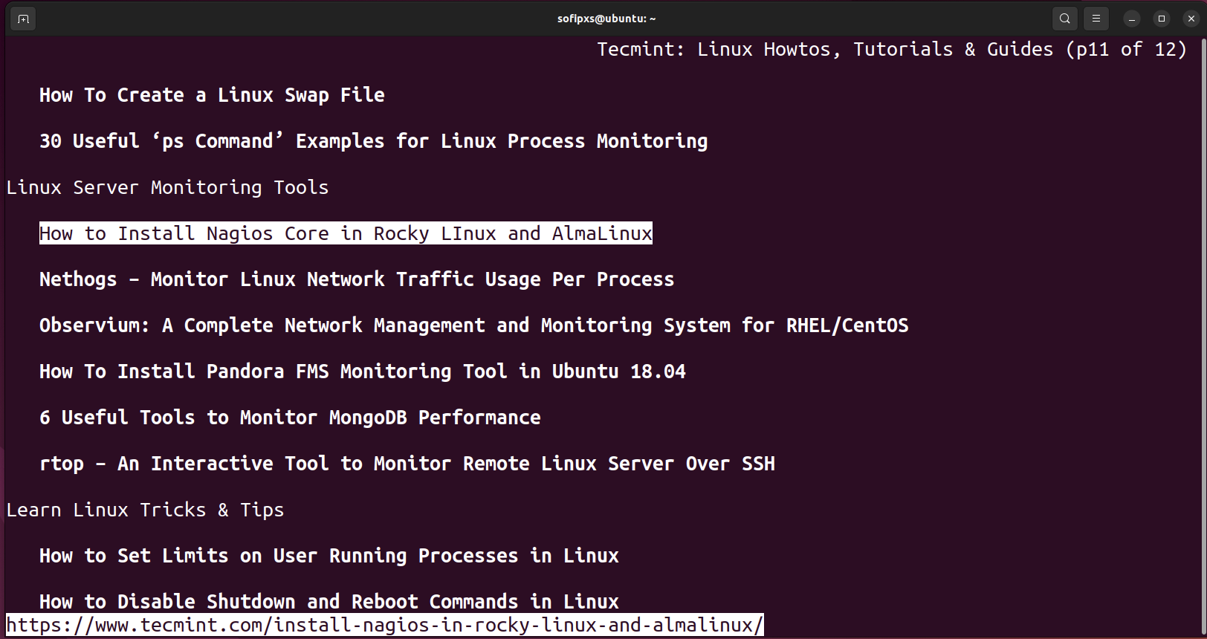

* Перегляд електронної пошти в терміналі.

Mutt is probably one of the most popular text-based email clients. It supports all the common features that one would expect from an email client. Color coding, mail threading, POP3, and IMAP are all supported by Mutt. But one of its best features is it’s highly configurable. Indeed, the user can easily change the keybindings, and create macros to adapt the tool to a particular workflow.

For Ubuntu, run sudo apt-get install mutt to install the mutt program. After installation, open a terminal and enter the mutt command. The mutt program will start and you will see your mailbox.

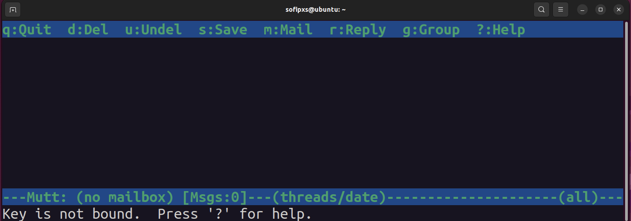

To send an email, press the m key. Enter the recipient's address, a subject line, and a message.

* Слухати музику через термінал.

MOC or Music on Console is a command line music player for Linux and Unix-like systems. All you have to do is install the player, select a file from a directory using the MOC menu, and all files in that directory will start playing starting from the selected file. MOC is an easy to use but powerful tool. It supports a number of audio formats such as OGG Vorbis, Mp3s, Speex, Wave, wavpack, SID, AAC, MIDI and many others.

Install MOC on Linux Ubuntu: sudo apt install moc

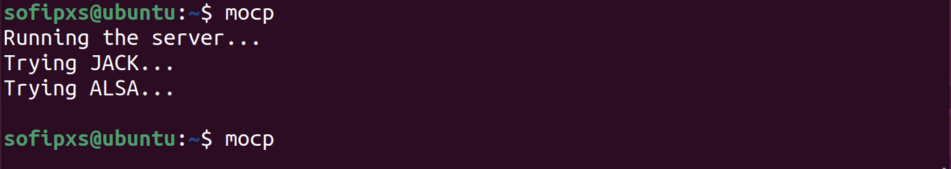

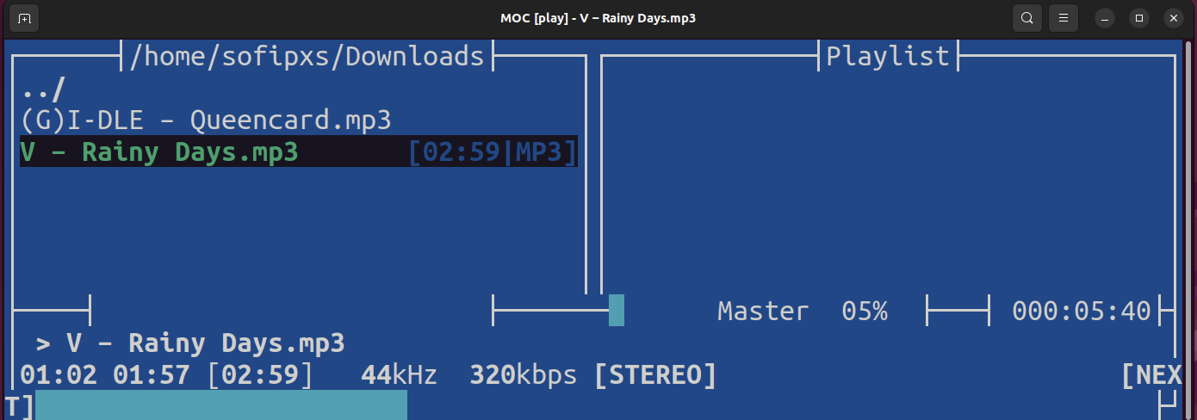

* Скачувати торенти через термінал.

There are many good CLI-based torrent clients, but few are as good as **transmission-cli.** It is the easiest to use out of all the choices out there and similar to the most-used torrent client on Linux (Transmission).

To install transmission-cli, open a terminal window and enter the following command: *sudo apt install transmission-cli.* Transmission CLI can download torrents directly from a URL by doing: *transmission-cli https://cdimage.ubuntu.com/ubuntu-mate/releases/22.04/release/ubuntu-mate-22.04.3-desktop-amd64.iso.torrent -w ~/Downloads.* This method is great if the user is in a pinch and just wants the download to happen as soon as possible.

**Aria2c** is a lightweight, and highly minimal download manager for Linux. Unlike Transmission and rTorrent, aria2c is a multi-protocol download client which means that you can also use it to download non-torrent files. You can obtain it by running the following command: *sudo apt install aria2c.*

To download a torrent with aria2c, run the program followed by the path of the “.torrent” file that you want to download. Just like in rTorrent, this could either be a local or remote path: aria2c https://cdimage.ubuntu.com/ubuntu-mate/releases/22.04/release/ubuntu-mate-22.04.3-desktop-amd64.iso.torrent

* Планувати дії в календарі та нагадувати про них через термінал.

cal: Display calendar.

remind: Set reminders.

gcalcli: Command-line interface for Google Calendar.

* Переглядати зображення в терміналі

1. Існують також дії які є класичними для більшості адміністраторів та мають досить різноманітний функціонал. Опишіть різні програми (команди, пакети) та встановіть по одній на кожну дію у терміналі:

* Вводити, редагувати, видаляти текст (редактори файлів).

Text editors:

nano: Simple and easy-to-use text editor.

vim: Powerful and highly customizable text editor.

emacs: Another powerful and extensible text editor.

* Здійснювати моніторинг процесів та ресурсів системи (аналог диспетчера задач або системного монітора в графічній оболонці).

2. System monitoring:

top: Display real-time information about running processes.

htop: Interactive process viewer with more detailed information.

ps: Show information about running processes.

free: Display memory usage.

df: Show disk usage.

1. Задачі, щоб підняти настрій посеред робочого процесу ☺ – так звані «пасхалки» (нажаль підтримуються не всіма дистрибутивами):

* Якщо Ви мрієте про подорож, то термінал може Вам показати зображення парового локомотиву з вагоном (гарний натяк на дорогу).

Run the command sudo apt install sl after booting, use sl

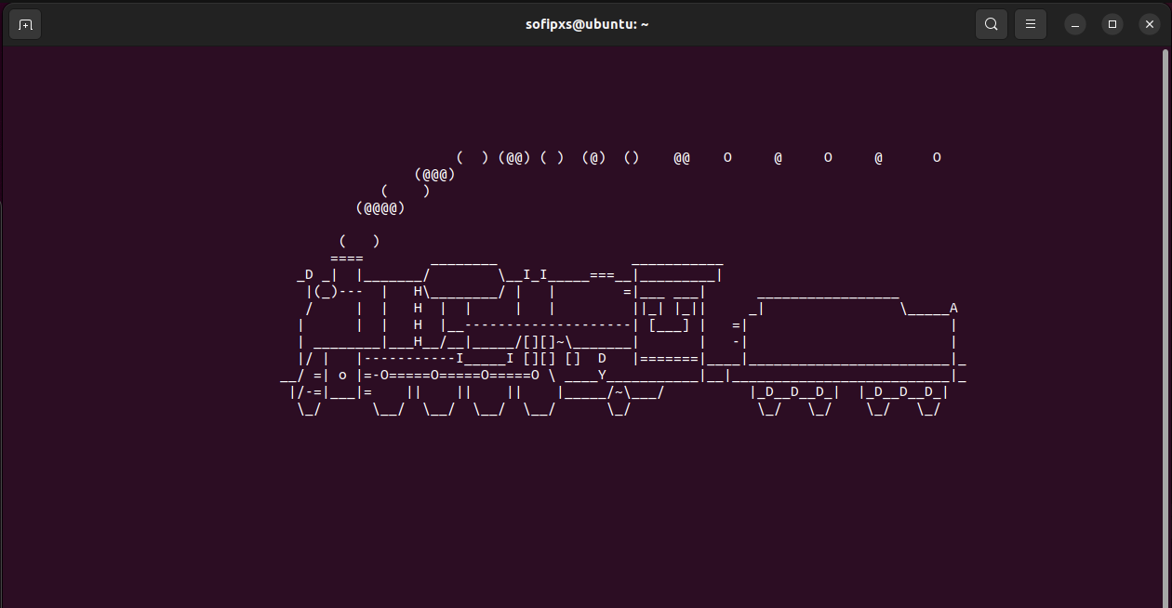

* Якщо Ви фанат зоряних війн, то термінал може їх Вам показати.

Enter the telnet command towel.blinkenlights.nl and press Enter. You will see an animated Star Wars film in ASCII art style.

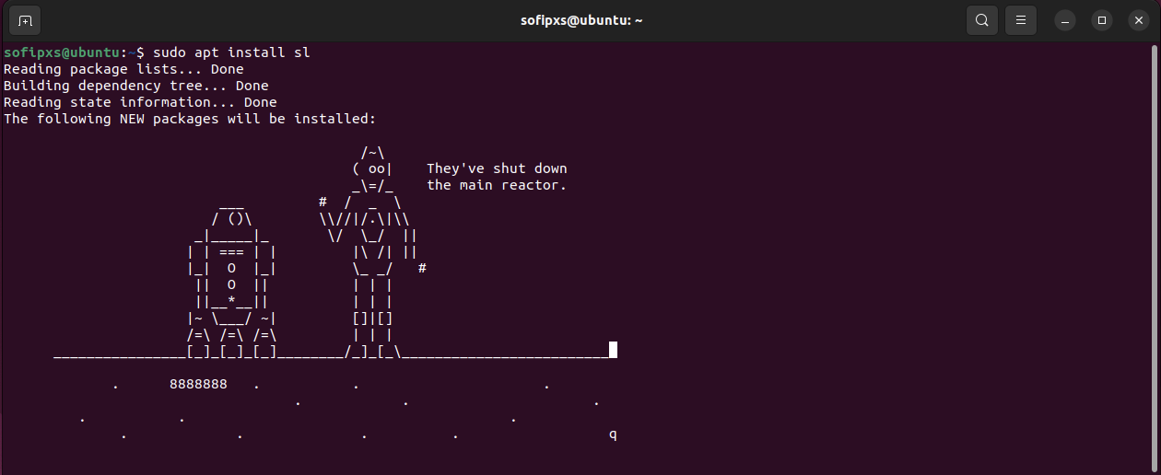

* Якщо ви любите тварин, то термінал Вам може організувати діалог з коровою.

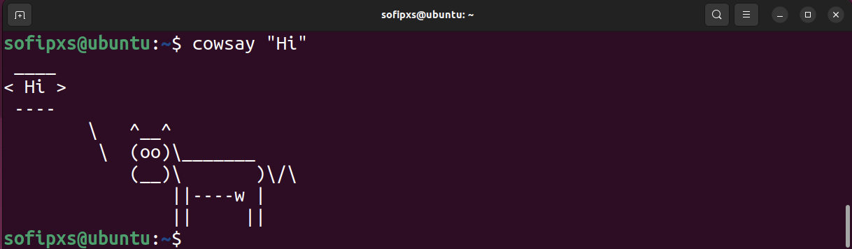

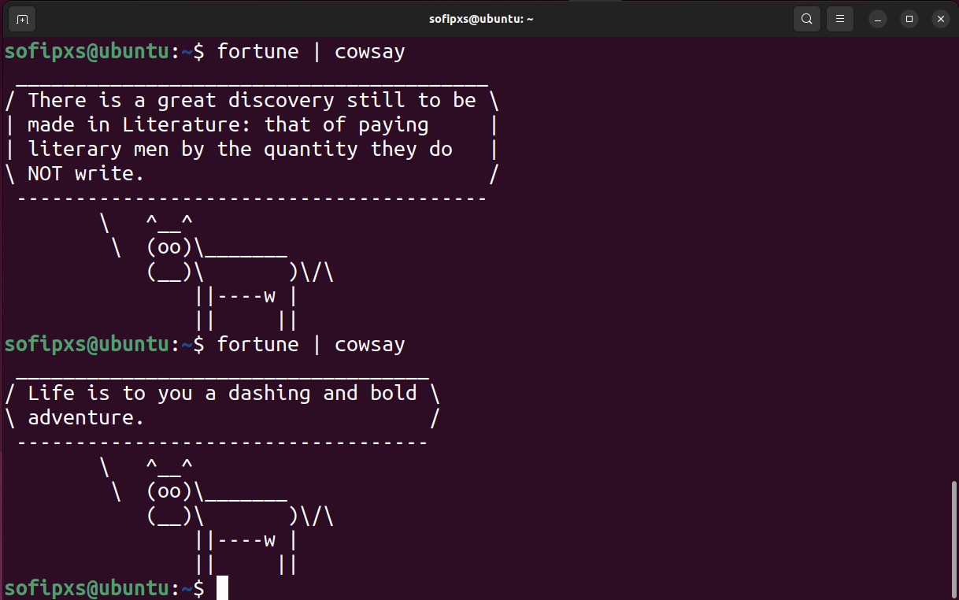

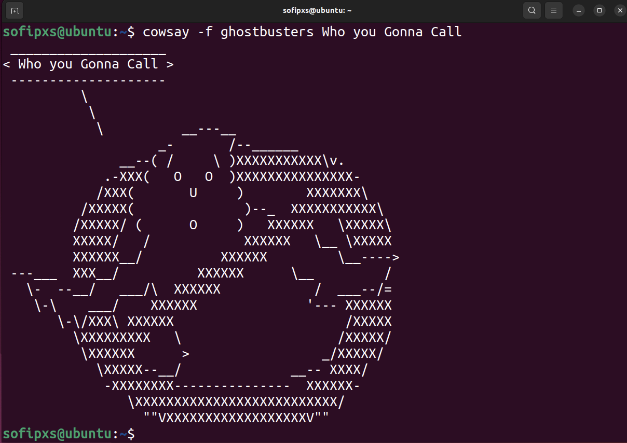

* Можливо Ви знаєте якісь цікаві інтерактиви, які не знаю я, то поділіться ними зі мною :)))

Command: sudo apt-get install cmatrix -> cmatrix -C red"

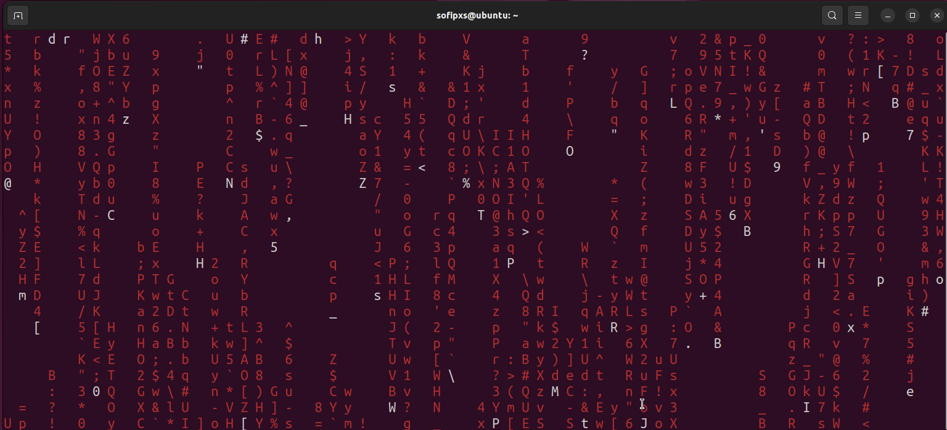

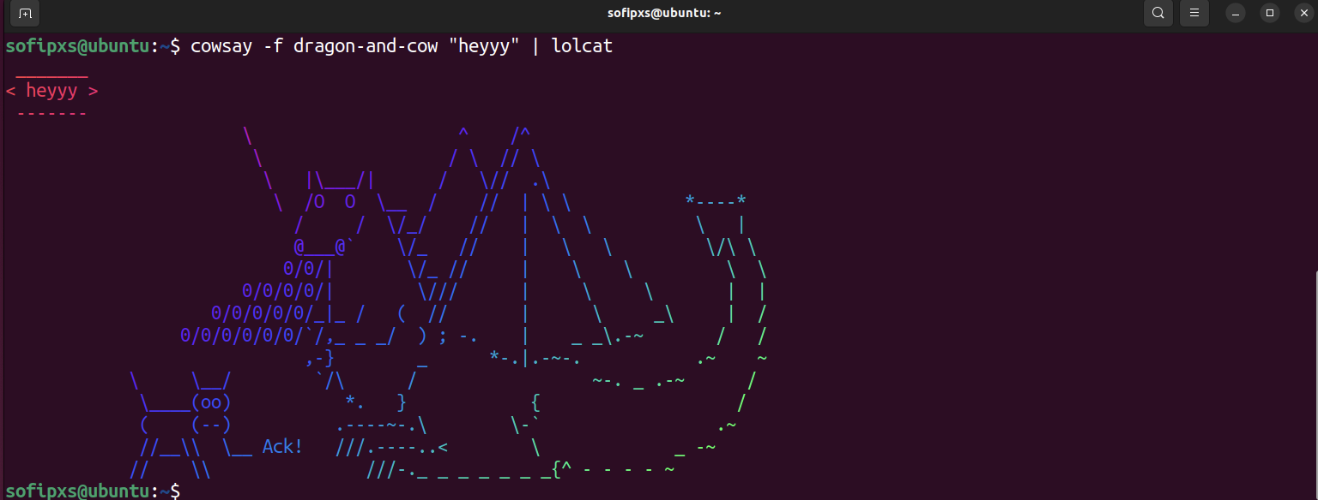

Command: sudo apt install oneko. Once oneko is installed, you run the command to see a small animated cat on your screen.

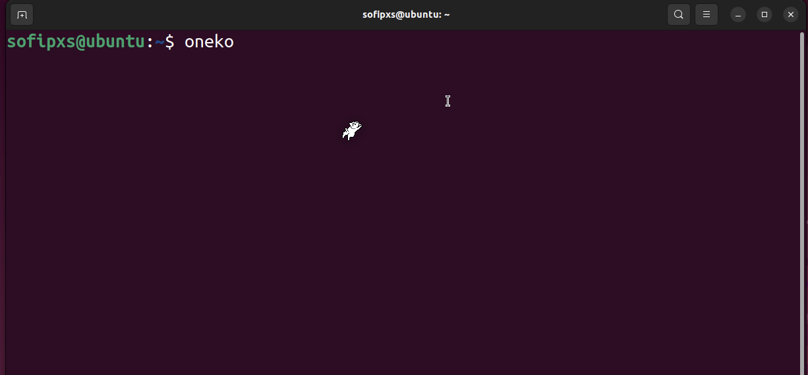

Command: telnet mapscii.me.

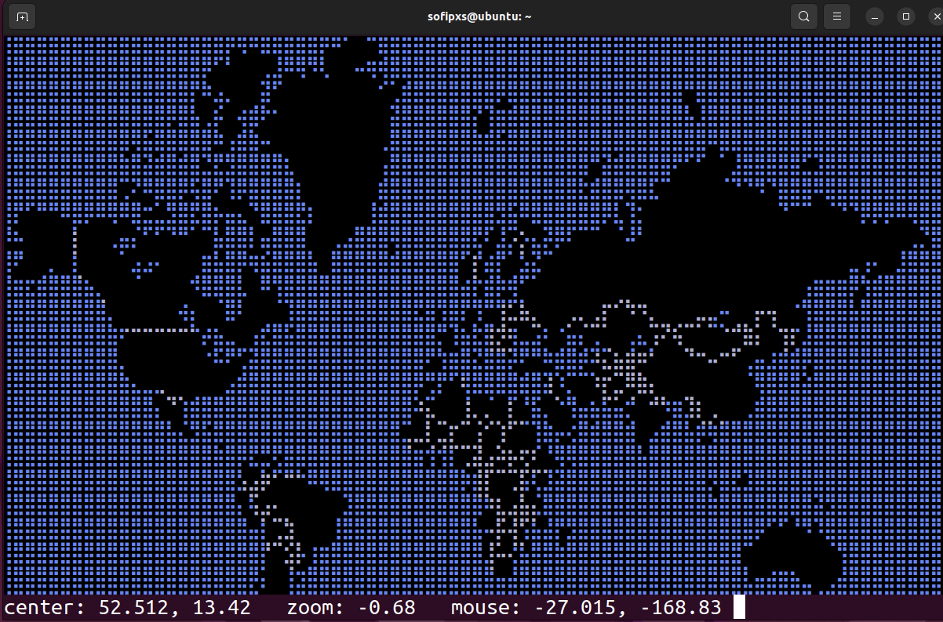

**Висновки:**

In the course of the work case, I considered various possibilities of working with a terminal in Linux. This included viewing files and folders, browsing the web, working with e-mail, listening to music, downloading torrents, scheduling calendar events, viewing images, and installing various programs to enter, edit, and delete text, as well as to monitor system processes and resources. This web case demonstrates that a Linux terminal can be a powerful tool not only for administrative tasks, but also for entertainment and creative interaction with the system.